OpenCart Website
Tutorial 8 — Test Case Execution & Summary (TestLink style)
Module Name: OpenCart – Login Module
Report ID: TR8_001
Webpage URL: https://demo.opencart.com/TlbeVW/ (administration login)

Aim
To prepare and execute test cases for the Login module of the OpenCart website and summarise the results.

Parameter Details
Module Name | Login Module
Project Name | OpenCart Website Testing
Application | OpenCart (opencart.com) – executed on the official demo store, demo.opencart.com
SDLC Model | Waterfall Model
Test Environment | Windows / Google Chrome
Tester Name | Student Name
Test Date | 15/08/2026

Test Cases
TC ID | Scenario | Input | Expected Result | Actual Result | Status
TC001 | Valid Login | Username demo + correct password (administration login) | Login successful; Dashboard opens | Login successful; Administration Dashboard opened | Pass
TC002 | Invalid Password | Registered username + wrong password | Error message shown; user not logged in | No execution evidence supplied | Not Executed
TC003 | Blank Username | Username empty + any password | Validation/error message shown | No execution evidence supplied | Not Executed
TC004 | Blank Password | Valid username + empty password | Validation/error message shown | No execution evidence supplied | Not Executed
TC005 | Unregistered User | Non-existing username + any password | Error message shown; user not logged in | No execution evidence supplied | Not Executed
TC006 | Forgotten Password Link | Click 'Forgotten Password' link | Password reset page opens | Link is visible on the storefront login page; click not captured | Not Executed

Execution Evidence
TC001 — Valid Login
Steps
- Open the demo administration login page (demo.opencart.com/TlbeVW/).
- Enter username "demo" and the correct password.
- Click Login.
- Observe the response.
Expected Result: Login successful; Dashboard opens
Actual Result: Login successful; Administration Dashboard opened (Total Orders 3.1K, Total Sales 6.6M, Total Customers 36.1K).
Status: Pass
Screenshot:
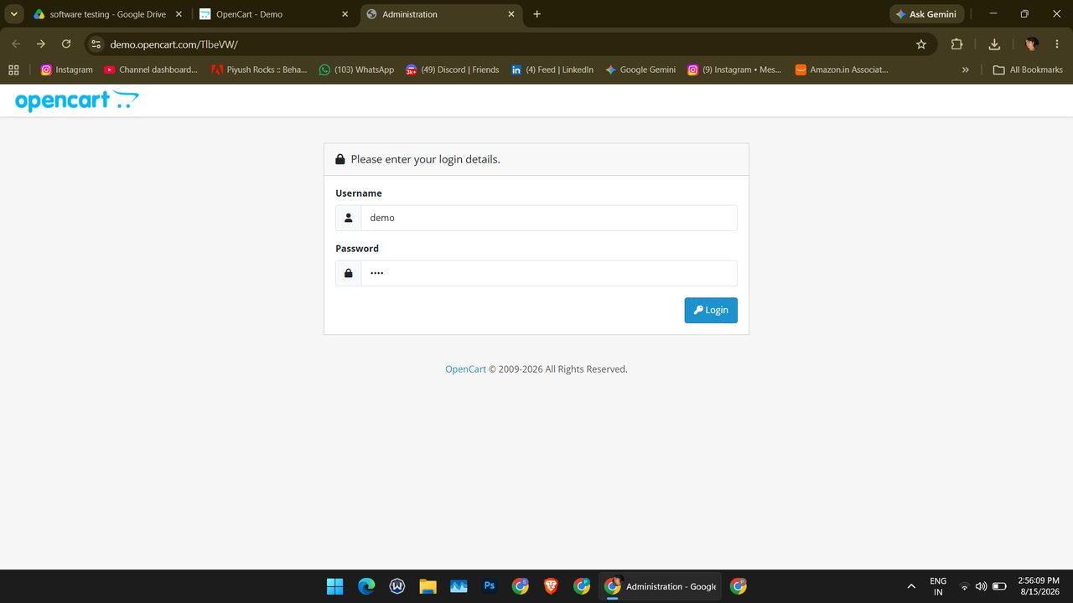
Screenshot (131)
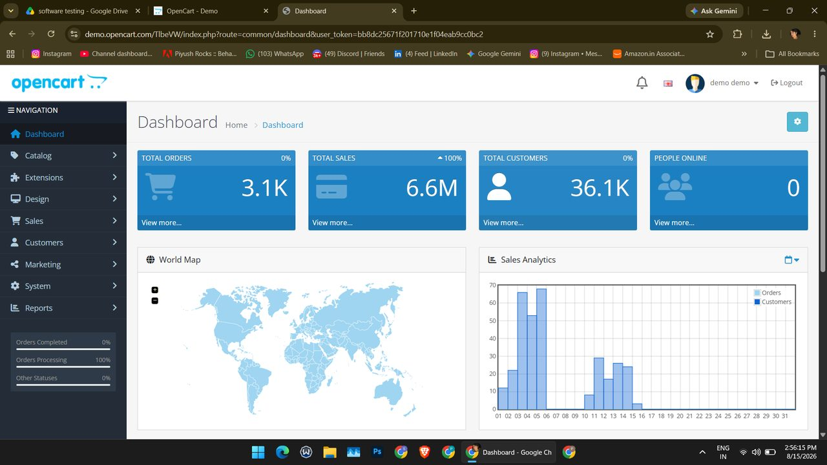
Screenshot (132)

Summary of Execution
Metric | Value
Total test cases | 6
Executed (Pass + Fail) | 1
Passed | 1
Failed | 0
Blocked | 0
Not Executed | 5
Pass % of executed | 100.0%
Pass % of total | 16.7%

